# CS 255 System Design Document Template

This template lays out all the different sections that you need to complete for Project Two. Each section has guidance to prompt your thinking. You will need to continually reference the interview transcript as you work to make sure that you are addressing your client’s needs. There is no required length for the final document. Instead the goal is to complete each section based on what your client’s needs are. Remove this note when you are finished, and replace all bracketed text with the relevant information.

## UML Diagrams

### UML Use Case Diagram

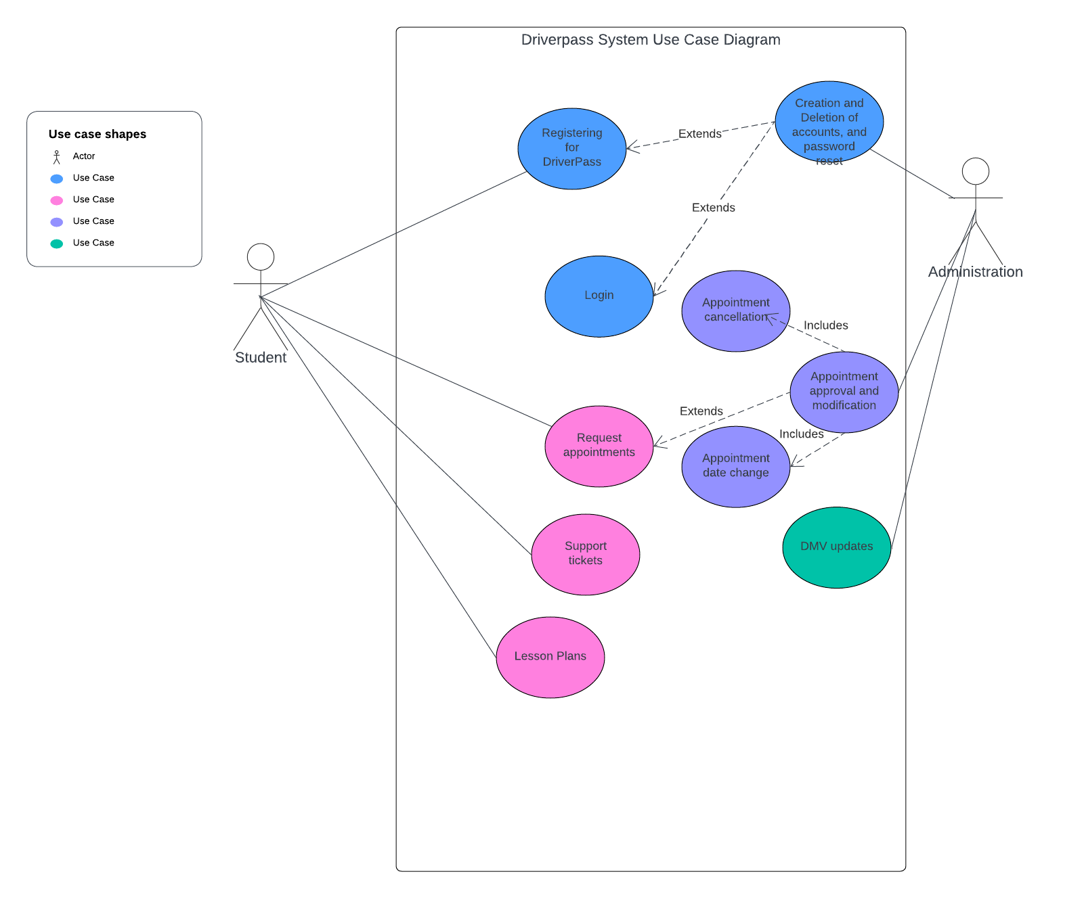

### UML Activity Diagrams

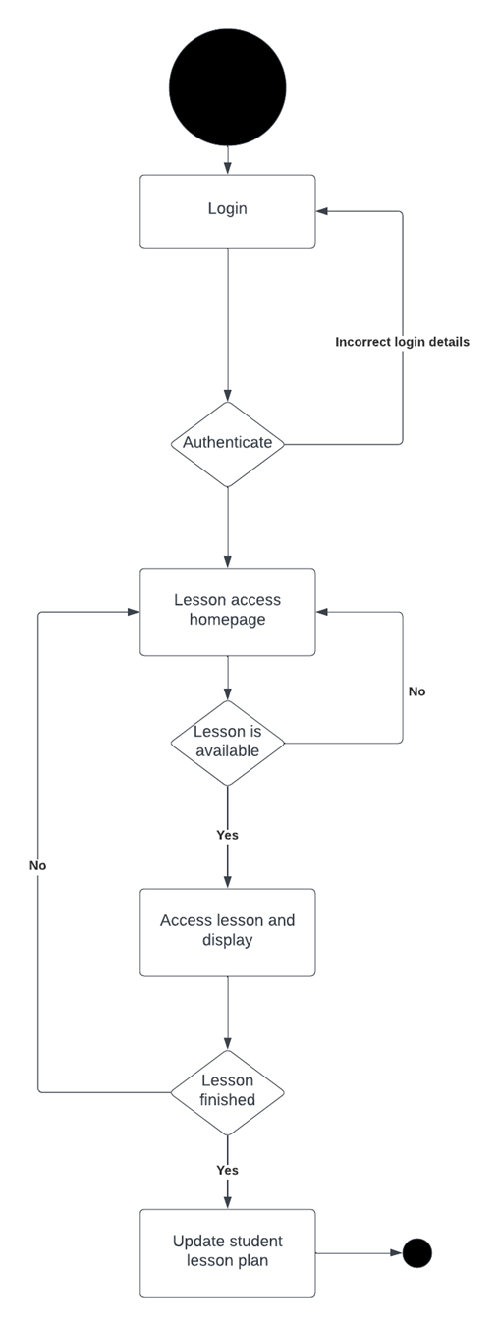  
Use case 1: Lesson Access and Lesson plan update. A student logs in, student login details are authenticated. Student then attempts to access a lesson from the lesson homepage. If that lesson is available for the student, the lesson begins. If the lesson is finished, the student’s lesson plan is then updated and the lesson ends. If not, the student is returned to the lesson homepage.

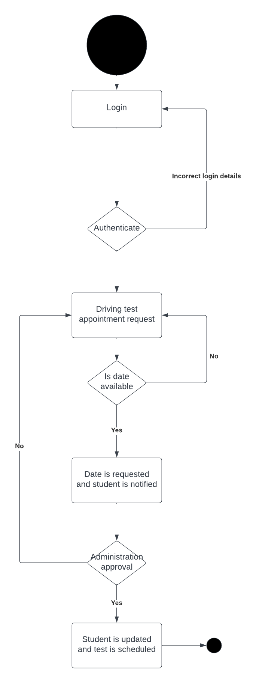

Use case 2: Driving test appointment request. Student logs in and is authenticated. Student then requests a date for a driving test. If the date is available, the date is requested and both student and admin are notified. If the date is approved, student is notified, and test is scheduled.

### UML Sequence Diagram

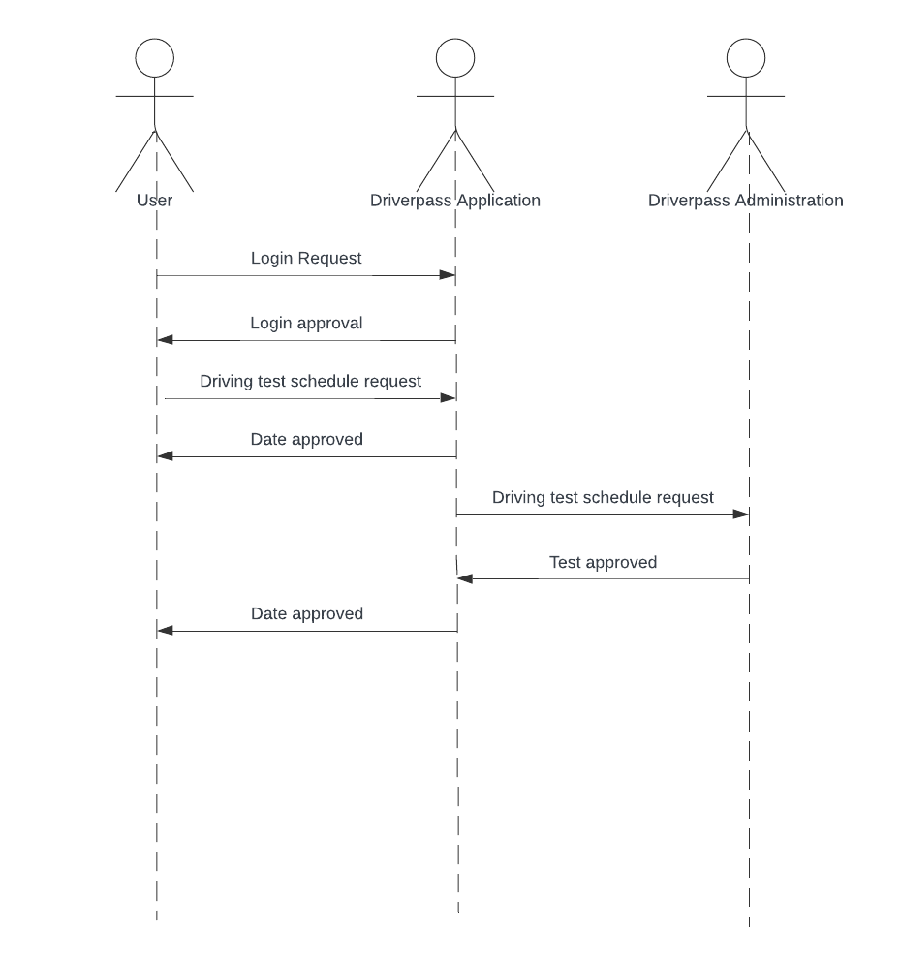

### UML Class Diagram

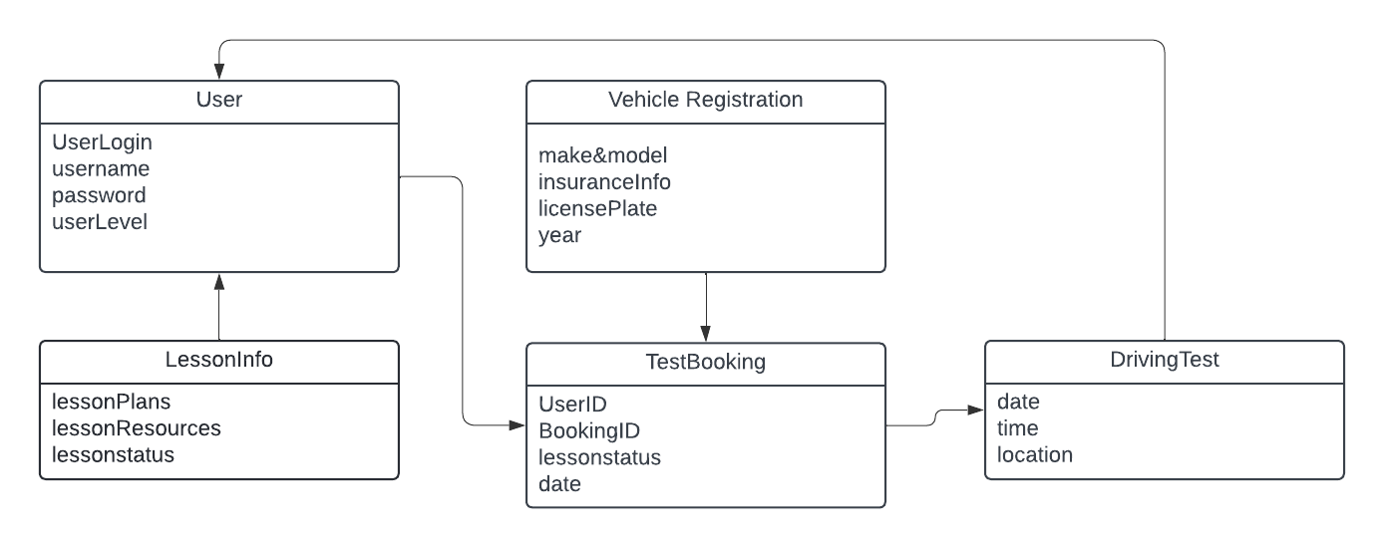

## Technical Requirements

The Driverpass system requires several different facets of hardware, including a server for Student information storage, Lesson data and access, vehicle information, and driving test information. This necessitates a large amount of writable storage. Driverpass is not very resource demanding in other ways, however, and will run on less expensive hardware. Software needed is included in Driverpass, though admin and students will need a way to download Driverpass or access it via the internet.